Hazardous Material Spill Response Guidelines
These guidelines will help you address a hazardous spill. If it is a minor spill, you are trained, feel comfortable, and it is safe follow steps 1 – 6 to clean up the spill. If not, call EHS 4-6200.
Call 911 and EHS (4-6200) if:
- Life threatening emergency
- Serious injury or contamination
- Major spill or high risk chemicals involved
- Environmental release
- Unknown material
- Secure the Area and Minimize Exposure
- Notify personnel in area
- Restrict access
- Place “Caution” signage
- Attempt clean-up only if trained and feel comfortable and safe
- Review Safety Data Sheet prior to cleaning spill
2. Wear Appropriate PPE
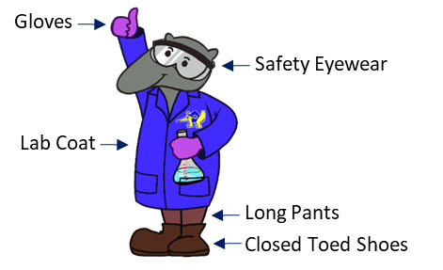
3. Conduct a Risk Assessment;
if Minor Low-Risk Spill (limited toxicity, flammability, volatility) Use Spill Kit
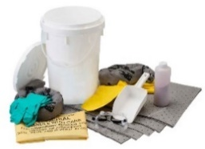
- Absorbent material
- Waste bags/sharps containers
- Dustpan-broom
- Tape/Ziptie

4. Contain the Spill
- Start outside of spill to center
- Use appropriate absorbents based on chemical
- Protect floor drains
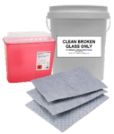
- Use tweezers, tongs, forceps, or dustpan-broom to collect sharps and broken glass (do not pick up sharps with hands)
- Place in appropriate sharps/broken glass container
5. Biohazard Spills Only
- Use absorbent pads or paper towels to cover spill
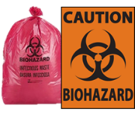
- Slowly pour freshly prepared 10% bleach from outside to center of spill
- Allow to sit for 30 minutes
- Use Biohazard bags for waste
6. Collect and Dispose
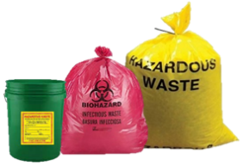
- Use leak-resistant bags
- Double-bag
- Mark bag with full chemical name, concentration (if known), and date
- Place bags in chemical waste or spill bucket
- Decontaminate area with compatible disinfectant
- Contact EHS for disposal (https://www.ehs.uci.edu/programs/enviro/)
- Restock the spill kit
Report Spill to your Supervisor and EHS (949-824-6200)
For follow-up and to refill your spill kit
4600 Health Sciences Rd • Irvine, CA 92697 • (949) 824-6200 • safety@uci.edu

Safety Moment:
Hazardous Material Spill Response Guidelines

I have reviewed and understand the contents of this Safety Moment document.

Name (print) | UCInetID | Signature | Date

