Standard Operating Procedure

High Performance Liquid Chromatography (HPLC)
Department:
Completion Date:
Approval (by PI / Lab Manger) Date:
Principal Investigator:
Principal Investigator Signature:
Internal Lab Safety Coordinator/Lab Manager:
Lab Phone:
Office Phone:
Emergency Contact: | (Name and Phone Number)
Location(s) covered by this SOP: | (Building/Room Number)
Type of SOP: ☐ Process ☐Hazardous Chemical ☐ Experiment ☐Equipment Use
Contents

Purpose and Scope
Responsibility
Definitions
Specific Hazards and Controls
General Hazard Control(s)
Location of Nearest Emergency Safety Equipment
Step-by-step Operating Procedure
Special Handling Procedures, Transport, and Storage Requirements
Preventive Maintenance

Monitoring and Safety Systems
Waste Disposal/Cleanup
Emergency Response Plan Procedure
References
Preventive Maintenance
Monitoring and Safety Systems
Emergency Response Plan
References
Additional Notes and Attachments
Documentation of Training
Read and review any applicable manufacturer/vendor safety information before developing standard operating procedure and performing work
*** NOTE: Each section needs to be complete with clear and detailed information based on the blue/italic font instruction. SOP must be approved and dated by the PI or lab supervisor.
- Purpose and Scope of Work/Activity:
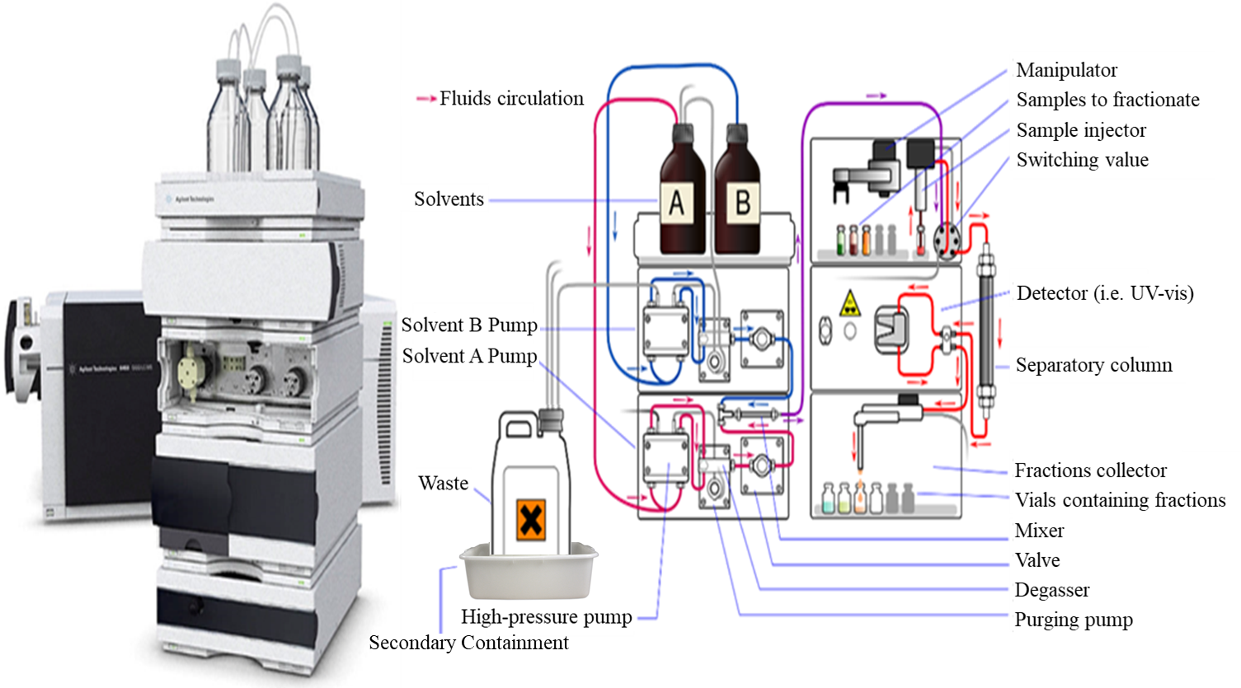
High performance liquid chromatography or HPLC is a method of column chromatography in which the mobile phase (a sample mixture or sample dissolved in solvent) is pumped through a stationary phase (typically a column packed with chromatographic material) at high pressure. HPLC is used to identify, quantify, or purify the individual compounds within a mixture. The sample is moved through the system using a carrier gas stream. The retention time (the amount of time that the analyte takes to move through the system) of each sample varies depending on the compound being analyzed, the solvent used, and the stationary phase.
The information below addresses general laboratory safety concerns while setting up and operating an HPLC. Modify this SOP with your laboratory’s specific operational procedures with the help of the Principal Investigator and verify the SOP with EH&S approval prior to working with an HPLC. Ensure that the laboratory specific procedures outlined in this SOP are followed by laboratory workers at all times. This document is not designed to substitute hands-on training and supervision by experienced laboratory personnel.
- Responsibility
Identify the personnel that have a primary roles in the SOP and describe how their responsibilities relates to this SOP. If necessary, include contact information.
Principle Investigator
- Must provide their laboratory with a copy of this SOP, must sign this SOP, and ensure that all members of their laboratory sign and understand this SOP
- Must ensure that their laboratory personal have obtained the appropriate general laboratory safety training, laboratory specific training, and any refresher training
- Must ensure that trained personal conduct repair and maintain on the HPLC as needed
Laboratory Personal
- Must obtain all necessary laboratory safety training, refresher training, and laboratory specific training
- Must read, sign, understand, and follow this SOP when using the rotary evaporator
- Must read the safety data sheet (SDS) for any compound that is being used as the mobile phase or as the sample for HPLC

- Definitions
In this section, define any acronyms or abbreviations that are used in the procedure.
HPLC: High Performance Liquid Chromatography
SOP: Standard Operating Procedure
SDS: Safety Data Sheets
- Specific Hazards and Controls
4.1. Chemical Hazards
The chemical hazards vary depending on the experiment. Flammable organic liquids are often used as the mobile phase for HPLC. The sample that is being analyzed may be toxic, biohazardous, flammable, etc. All the necessary precautions for these compounds should be taken into account when conducting work with an HPLC. Always read the SDS for any compound that is being used as a solvent or as the analyte for HPLC.
List all of the specific chemicals typically used and their hazards.
Chemical/Material (Name, Cas #, other ID) | Hazards | GHS Symbol
Health Hazard | Flame | Exclamation Mark
 | 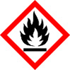
Gas Cyliner | Corrosion | Exploding Bomb
Flame Over Circle | Environment | Skull and Crossbones
 |  | 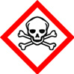

Example: Methanol (67-56-1) | - highly flammable  - toxic if swallowed, inhaled, or in contact with skin  - causes eye damage

4.2. Hazards and Controls
In general the main hazards and controls associated with HPLC are:
Risks and Hazards | Controls
Chemical Exposure | - Personal protective equipment should be worn at all times.  - Prepare any solutions for HPLC in a fume hood to ensure adequate ventilation and prevent inhalation.  - Ensure that solvent reservoirs and waste container are air-tight, in secondary containment and do not allow the solvent vapors to enter the room.  - Never leave the waste containers open, or cover them with foil or parafilm. Examples are shown below. This type of method will led to hazardous vapors being released into the laboratory environment.  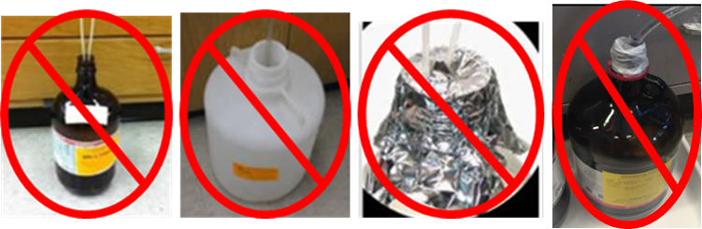  - Appropriate methods of covering solvent reservoirs and waste containers include using a sealed cap with or without threads as shown below.  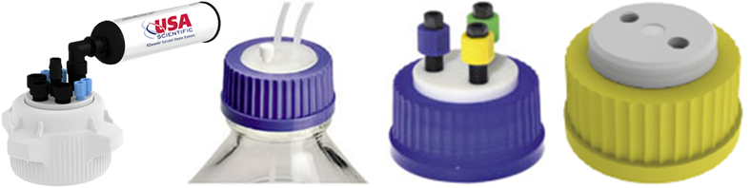  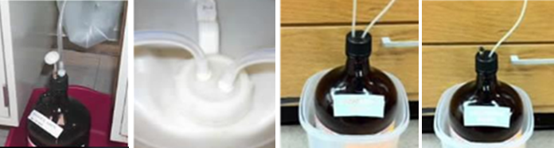  - When possible, HPLC waste vessels should be located in a fume hood or should exhaust into a fume hood.
Other Chemical Hazards | - Always read the SDS for every chemical used and take the necessary precautions for all hazards.
High Pressure | - Ensure that the pressure is behaving normally and is well below the maximum pressure for the HPLC system.  - Liquids under pressure can cause an eye injury if a leak occurs. Make sure to always wear the appropriate eye wear (safety goggles or glasses)
Fire | - Electrical faults can cause a fire  - When flammable chemicals are used a spark from the instrument can easily start a fire.  - Ensure that the system is properly serviced and maintained to avoid electrical malfunctions.  - Do not have any ignition sources at or around the HPLC
Mechanical or Electrical Problems | - The HPLC should be routinely serviced or inspected regularly by a trained profession.  - If you suspect that there is a mechanical or electrical problem stop using the instrument and ensure that it is inspected.  - When preparing samples only use volatile buffers and samples. Addition of salts to the instrument will cause precipitate, this will cause the need for maintenance.

- General Hazard Control(s)
5.1. Engineering/Ventilation Controls
If possible, HPLC waste vessels should be located in a fume hood and should exhaust into a fume hood. The entire HPLC system does not need to be in a fume hood, but it should be in a well ventilated negative pressure room.
5.2. Administrative Controls
- Documentation
  - The HPLC standard operating procedure (SOP) must be completed and signed by every member of the laboratory
  - Safety data sheets (SDS) for each material should be reviewed prior to use
  - Manufacturer operating manual should be reviewed prior to use
- Training
  - Training must be completed prior to working in the laboratory
  - Process specific training must be completed prior to working with an HPLC
  - Basic mandatory trainings include laboratory safety fundamentals, hazardous waste management, and hazardous materials incidents emergency procedures

5.3. Personal Protective Equipment
EYE PROTECTION: ANSI Z871-compliant safety glasses or safety goggles
PROTECTIVE CLOTHING: Lab coat (flame resistance if working with flammables) and appropriate chemical resistant gloves.
Appropriate clothing must be worn under the lab coat: long pants, full length shirt, and closed-toed/heeled shoes.
- Location of nearest emergency safety equipment
Items | Location
Eyewash/Safety Shower
Chemical Spill kit
First aid kit
Fire extinguisher
Telephone
Fire alarm manual pull station
Others/Details:

- Step-by-step Operating Procedure
Provide the steps required to perform this procedure.
For a process: Write enough detailed description of the procedure to guide the user through the process including details of startup, normal condition operation, temporary operation condition and emergency shut-down, etc.
Also cover enough information as following:
- Chemical concentrations, gas amount
- Pressure limits, temperature ranges
- Flow rates
- Special safety equipment is to be utilized.
- Schematics or pictures for complex setups.
- Highlight safety precautions put in place
- What to do when an upset condition occurs
- What alarms and instruments are pertinent if an upset condition occurs
- If lockout/tagout is required
Some tips:
- Use numbers for steps and sub-steps that have to be performed in a specific sequence
- Use bullets for steps or items that can be performed in any order.
- Solicit ideas for other users.
- Include a flow diagram to help interpret more complex procedures.
- Include pictures and label different components.
For Equipment: Describe the step-by-step procedure for using the equipment properly. Include details for potential equipment failure if something is done improperly in the procedure. Describe how to power down the equipment at the end of use.
A basic procedure is supplied for you below, make sure to include a procedure for your specific instrument and process.
BASIC OPERATING PROCEDURE
Edit this procedure to reflect your laboratory’s and your HPLC instrument’s specific procedure. The procedure below is meant to offer a general procedure for guidance and safety considerations when using an HPLC.
- Read the SDS for all materials.
- Prepare the analyte solution in a fume hood.
- Make sure the solvent reservoirs are filled before using the instrument.
- Make sure that you are using the correct mobile phase.
  - If you are changing the mobile phase, completely wash all lines and columns before use.
- Ensure that the pump lines have been purged of air bubbles and check the system for leaks before beginning the analysis.
- Turn on the HPLC and equilibrate the mobile phase solution.
- Make sure that the pressure is behaving normally and is well below the maximum pressure for the HPLC system.
- Constantly monitor the solvent levels in the solvent mobile phase bottles, NEVER let them run dry.
- Click the ‘injection’ icon button (or the equivalent on your instrument). Inject the background into the instrument.
- Once the background has stabilized, then inject your sample into the instrument.
- The HPLC column should be washed for at least 30 minutes after each run to ensure that it is properly cleaned. The procedure for washing the column and inject will vary depending on the instrument and on the sample that is being analyzed.
- Turn off the HPLC.
- Dispose of all waste in the appropriate hazardous waste containers.

- Special handling procedures, transport, and storage requirements
Describe special handling and storage requirements for hazardous chemicals/gases in the laboratory, especially for highly reactive, unstable and highly flammable materials and corrosives. Describe transport and secondary containment requirement, between the laboratories or between facilities.
- Preventive Maintenance
Clean up and preventive maintenance is important for keeping equipment in safe working order. In this section, any regular maintenance and / or calibration frequency for research equipment, instrumentation and/or facilities should be included here.
Always ensure that the mobile phase and sample filters are present and in proper working condition.

Degas the mobile phase to prevent the introduction of air bubbles. Always use HPLC grade solvents.

Inject clean or filtered samples when possible, to prolong injector and column life.

Flush/rinse the instrument to ensure there is no buildup of residual sample or residue.

Change the seals and O-rings according to a regular schedule recommended by the manufacturer.

- Monitoring and Safety Systems
This section includes a list of all monitoring systems such as gas detectors, safety interlocks, equipment guards, fail safe control logic, etc. noted.
- Waste Disposal/Cleanup
Dispose of any hazardous waste generated through UCI EH&S. A hazardous waste pick up can be scheduled by completing a Hazardous Waste Pick up Form, via the internet, www.ehs.uci.edu/programs/enviro/ or texting hwp@uci.edu (detailed instructions can be found at https://www.ehs.uci.edu/apps/waste/Text%20a%20Chemical%20Waste%20Request.pdf or https://www.ehs.uci.edu/apps/waste/text_to_collect.jsp).
- Emergency Response Plan
In this section describe any special procedure for spills, releases or fire. Indicate how accidental events should be handled and by whom. List emergency contact number.
Additional emergency procedures: Describe additional, local emergency procedures.
First Aid Procedure
If inhaled
- Move to fresh air
- Have victim rest in half-upright position
- Seek medical attention immediately
In case of skin or eye contact
- Immediately flush skin or eyes (eyewash station) with plenty of water for at least 15 minutes
- Remove contaminated clothing and shoes
- Get medical attention immediately
If swallowed
- Do not induce vomiting unless directed to do so by medical personnel and never give anything by mouth to an unconscious person.
- Loosen tight clothing such as a collar, tie, belt or waistband.
- Get medical attention immediately
Life-threatening emergencies (Such as: fire, explosion, large-scale spill or release, compressed gas leak, valve failure, etc)
- Evacuate the room and close the door behind you
- Secure the room to prevent entry
- Alert people in the area and activate the local alarm systems
- Call 911 – Tell the dispatcher the name of the gas or chemical.
- Provide local notification
- Report to EH&S at x4-6200 within 8 hours
- Complete online incident report at https://www.ehs.uci.edu/apps/hr/index.jsp
Identify the area management staff that must be contacted and include their work and home numbers. This must include the PI and may include the safety coordinator and facility manager.
In case personnel exposed or injured
- Remove the victim from the area if it is safe to do so
- Follow first aid protocol as mentioned above
- Provide safety data sheets (SDSs) for all chemicals to Emergency Medical Technician (EMT) or to the hospital
- Report to EH&S x4-6200
- Complete the online incident form https://www.ehs.uci.edu/apps/hr/index.jsp or Human Resources, Workers Compensation at x4-9152
Non-life threatening emergencies
- Notify your supervisor or faculty staff
- Report to EH&S x4-6200
Identify the area management staff that must be contacted and include their work and home numbers. This must include the PI and may include the safety coordinator and facility manager.
For spill & accident procedure
In the event of a small spill or release that can be cleaned by a trained local personnel follow below steps:
- Use appropriate personal protective equipment and clean up material for chemical spilled
- Double bag spill waste in clear plastic bags, label and schedule a chemical waste pick-up

- References
This section should include the references that were used to produce this SOP.
- Ahmad, Z.; Coleman, N.; Shepherd, N. High Pressure Liquid Chromatography (HPLC). Standard Operating Procedure (SOP). Version: SMB019.3. The University of Sydney. Molecular Bioscience.
  - https://sydney.edu.au/science/molecular_bioscience/ohs/documents/sop/SOP%20SMB_019.3_High%20pressure%20liquid%20chromatography%20(HPLC)%20ZA%20NC%20NS%200714.pdf
- High Performance Liquid Chromatography. Purdue University. Radiological & Environmental Management Division of Environmental Health and Public Safety.
  - https://www.purdue.edu/ehps/rem/waste/hplc.html
- 8.4.5 Liquid Chromatography Waste. University of Minnesota Department of Environmental Health & Safety (DEHS).
  - https://dehs.umn.edu/845-liquid-chromatography-waste
- BAE. HPLC Standard Operating Procedure. Aminex 87-H and 87-P analytical columns. University of Kentucky, Biosystems and Agricultural Engineering Dept.
  - https://www.engr.uky.edu/sites/default/files/20141212-Primary%20SOP%20HPLC-H%20column%20V2.pdf

- Additional Notes and Attachments
In this section list any notes or attachments needed to implement this SOP.
- Documentation of Training
- Any deviation from this SOP requires approval from PI.
- Prior to conducting any work with the equipment, designated personnel must provide training to his/her laboratory personnel specific to the hazards and procedures involved in working with this process.
- The Principal Investigator must provide his/her laboratory personnel with a copy of this SOP and a copies of any SDS provided by the manufacturer for any chemicals used.
- The Principal Investigator must ensure that his/her laboratory personnel have attended appropriate laboratory safety training or refresher training annually.

I have read and understand the content of this SOP:
Name | Signature | Identification | Date

